**Assignment 2**

**Playing with files**

**1. Create a file like nano file1.txt**

**o Edit some data and then save the file**

**2. Now we will copy data from file1 to new file2**

**o cp file1.txt file2.txt**

**o Then see the output of file2.txt, cat file2.txt**

step 1: command touch file1.txt

step 2: command vim file1.txt

step 3: command cp file1.txt file2.txt

step 4: cat file2.txt

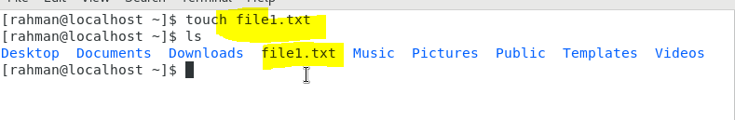

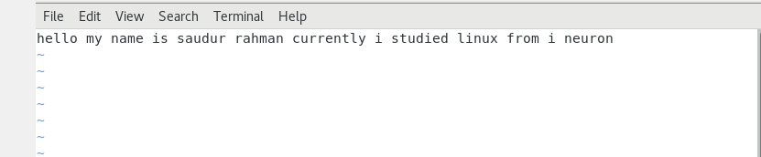

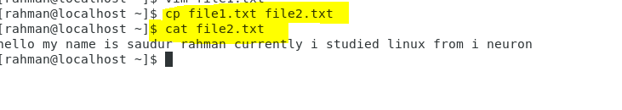

**we will move the file2.txt to new folder /home**

**o mv file2.txt /home**

**o Then go to home directory and check ls, file exits or not?**

Step 1: command mv file2.txt /home

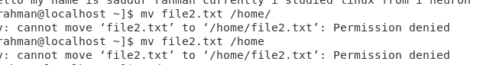

🡪It is not possible to send any file from one directory to another if you are not log in with root user

**Then we create a new file3.txt and file4.txt in home directory and add**

**content in it.**

**o Now do echo “Hello I am newline” > file3.txt and provide the**

**output of file3.txt**

**o Now do echo “Hello I am newline” >> file4.txt and provide the**

**output of file4.txt**

step 1: command touch file3.txt and file4.txt

step2: command echo “Hello I am newline” > file3.txt

step 3: cat file3.txt

step 4: command echo “Hello I am newline” > file4.txt

step 5: cat file4.txt

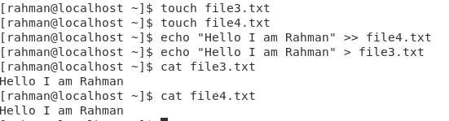

Now different b/w ‘’>” “>>”

“>” is used for change in files who already in the directory

“>>” it is also used for same but if the file is not in the directory it create the new file

**For remove a file or directory you can use the below two commands**

**o To delete a file – rm <any_filename>**

step1: command rm <filename file name ….>

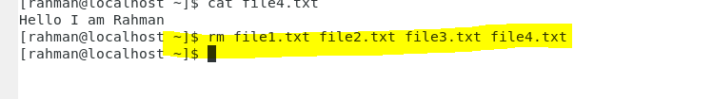**To delete a directory- rmdir <any_directry name>**

Step1 : rmdir directory name

